

OGAM
Global Architecture

Contents

1 Introduction 3
2 Software architecture 4
3 Services 5

Introduction

The platform is composed of a web site developed with the Zend Framework and some services developed in java and hosted in Tomcat.

Software architecture

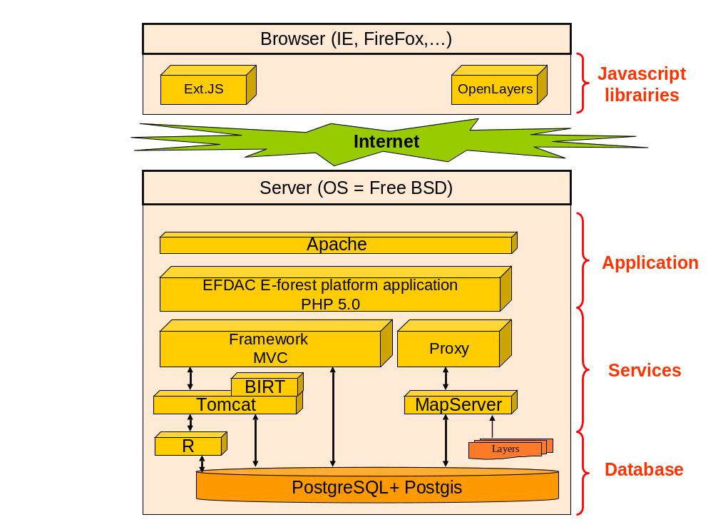

Services

The services are developed in JAVA and are deployed using Tomcat (see each service documentation for more details).

The services are sharing some common classes or methods, in the project a “service_common” directory contains these common classes.

Service common
Service integration
Service harmonization
Service interpolation

Service calculation

Extends
Service
Report Generation

